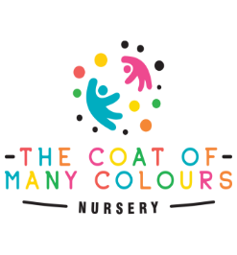Fees

**The deposit and registration fee**

**Full time: Part Time:**

Deposit : £350 Deposit : £225

Registration fee: £25 Registration fee: £25

**30 hour funding ONLY**

Deposit: £150

Registration fee: £25

**3months to 5 years old**

Full day (7:30am – 6pm) - £70 per day

AM session (7:30am – 1pm) £45 per session

PM session (1pm – 6pm ) £45 per session

**Basic full time fee:**

**Weekly :**  £350

**Monthly :** £1,516.66

**All full time fees are based on 52 weeks of the year and are divided by 12 months.**

**Nappies and wipes will be provided**

**Payment Details**

**Account Name:** The Kingsborough Centre

**Bank Name:**  Barclays Bank

**Bank Address:** 142 High Street Uxbridge, UB8 2JX

**Account Number:** 60792977

**Sort Code:** 20-89-16

**Additional hours: £10 per hour**

**Funding and additional session prices per day:**

*These are based on 5 days per week, for less days please ask for alternative costs.*

2 year old 15 hours funding

* 38 weeks (Term time) – £68.19
* 52 week - £62.30

3 year old 15 hours funding:

* 38 weeks (Term time) – £60
* 52 weeks - £62.30

3 year old 30 hours funding:

* 38 weeks (term time) - £50.10
* 52 weeks - £58.92

**Nappies and wipes will be provided**

**Funding session ONLY times**

**For 30 hours ONLY**

**Meals & Consumables: £10 per day.**

**15 hour funding ONLY children hours:**

**AM session**

8am – 1pm for 3 days per week

9am – 12pm for 5 days per week

**PM session:**

1pm -6pm for 3 days a week

1pm – 4pm for 5 days a week

**30 hour funding ONLY children hours:**

**AM session**

8am – 2pm for 5 days per week

8am – 6pm 3 days per week

**PM session:**

12pm – 6pm 5 days per week